**Title:** Hospital Dashboard Analytics: Enhancing Healthcare Performance with Data-Driven Insights

**Authors**: Kashianth Konade, Sujan Billava, Praveen Kumar Bura, Bharani Kumar Depuru.

**Abstract:**

**Many healthcare organizations face challenges with scattered data, inefficient use of resources, and difficulty in gaining useful insights. These issues affect hospital operations, patient care, and financial management. To solve this problem, this project aims to create a Healthcare Analytics Platform using Power BI to help hospitals track performance, improve decision-making, and enhance patient outcomes.**

**The platform will include interactive dashboards that provide customized views for doctors, hospital administrators, and other healthcare staff. These dashboards will show key performance indicators, trends, and real-time data to support better planning and management. Additionally, an AI-powered assistant will allow users to ask questions using simple language and get meaningful insights about hospital operations, patient care, and financial performance.**

**For hospital administrators, the system will help in managing resources, tracking bed occupancy, monitoring equipment usage, and improving patient experience. Meanwhile, doctors and medical teams will get insights into treatment effectiveness, infection rates, and patient recovery trends, helping them make better clinical decisions.**

**By combining real-time data analysis, AI-driven insights, and Power BI dashboards, this platform will help hospitals reduce costs, improve efficiency, and deliver better healthcare services. The system will present data in a simple, easy-to-understand format, making it accessible for all healthcare professionals.**

**Keywords:** Hospital Analytics, CRISP-ML(Q), Data Visualization, Power BI, Predictive Analytics, Healthcare Performance.

## **I. INTRODUCTION**

The healthcare sector persistently faces challenges in managing patient care, healing center resources, and money related operations. Proficient decision-making is significant to ensure that healthcare administrations run smoothly and effectively. In any case, conventional clinic administration depends on manual forms and inactive reports, which regularly come up short to provide real-time bits of knowledge. This confinement leads to delays in decision-making, misallocation of resources, and wasteful aspects in hospital operations [1].

To overcome these challenges, we introduce a Hospital Dashboard Analytics System, which integrates real-time information visualization, AI-driven analytics, and predictive experiences to enhance hospital performance. The system provides a centralized view of key performance indicators (KPIs), enabling healing center administrators, physicians, and operators to make data-driven decisions with more prominent precision and speed. This paper investigates the improvement, implementation, and impact of an intelligently dashboard custom fitted to optimize healthcare management [2].

By leveraging cutting edge information analytics apparatuses such as Power BI and AI-driven decision support systems, the proposed solution ensures productive monitoring of understanding flow, resource utilization, and money related performance. The dashboard offers real-time tracking of bed occupancy rates, understanding affirmations, treatment success rates, and operational productivity. Furthermore, predictive analytics capabilities allow hospitals to anticipate future trends, optimize staffing requirements, and enhance generally service conveyance. The following sections discuss the methodology, implementation, results, and future scope of the Hospital Dashboard Analytics System [3].

The project methodology followed here is the open-source CRISP-ML(Q)[5] methodology from 360DigiTMG(ak.1) [Fig 1.1], which stands for Cross Industry Standard Process for Machine Learning with Quality Assurance. This structured methodology ensures a systematic approach to problem identification, data preprocessing, model training, evaluation, and deployment. By following CRISP-ML(Q)[5], the project follows a well-defined lifecycle from data collection to real-world implementation, ensuring robust and efficient model performance.

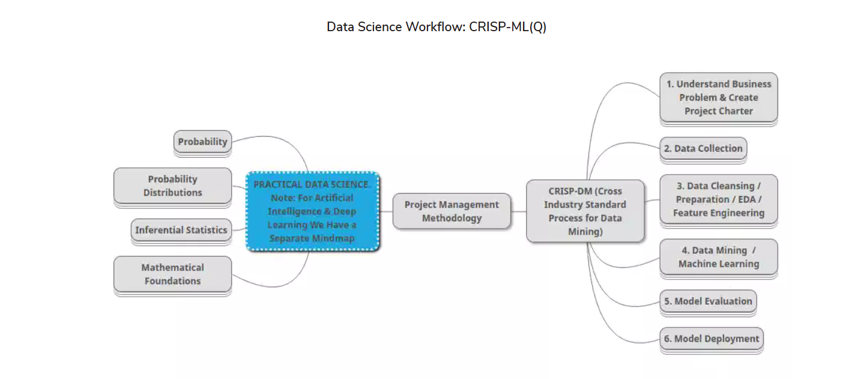

Fig 1.1: This Figure Depicts the CRISP-ML(Q) Architecture that We have followed for this Research Study.

(Source: Mind Map - 360DigiTMG)

## **II. METHODOLOGY:**

CRISP-ML(Q) Framework The CRISP-ML(Q) methodology ensures a structured and iterative approach to data analytics in healthcare [4]. The key stages are:

1. Data Understanding:

Identifying challenges such as resource task, determined hold up times, and recuperating center execution optimization.

Defining key execution pointers (KPIs) that alter with recuperating center targets.

Understanding the specific needs of accomplices, checking clinic chiefs, specialists, and budgetary teams [5].

2. Data Collection:

Collecting real-time and chronicled clinic information from sources such as confirmation records, budgetary data, and treatment histories.

The dataset for this investigates was collected from a client’s healing center administration framework, covering quiet affirmations, doctor plans, charging exchanges, and bed inhabitance rates.

Additional data was sourced from open healthcare databases, protections claim, and government wellbeing reports to give a comprehensive and assorted dataset.

Data was approved through exploratory data examination (EDA) strategies to recognize lost values, irregularities, and outliers [6].

3. Data Arranging:

Cleaning and organizing data into social tables such as Arrangements, Confirmations, Patients, Strategies, Specialists, Rooms, Beds, and Billing.

Using Python (Pandas, NumPy) to preprocess the data, guaranteeing consistency, precision, and standardization.

Data normalization and change strategies were connected to guarantee that values remained inside anticipated ranges.

Anomalies in persistent records were hailed utilizing measurable investigation to identify outliers [6].

4*.* Modelling:

Implementing data analytics models to track KPIs, counting quiet socioeconomics, recuperating center proficiency measurements, asset utilization, and budgetary performance.

Predictive models were utilized to estimate clinic bed inhabitance rates, understanding readmission probability, and regular affirmation trends.

AI-driven classification models were tried to portion quiet bunches based on restorative conditions and mending centre remain duration [8].

5*.* Evaluation:

Validating dashboard precision, proficiency, and convenience through partner input, real-world testing, and master reviews.

Conducting A/B testing with healing center staff to compare the modern dashboard against existing announcing systems.

Checking demonstrate execution utilizing measurements like precision, accuracy, review, and F1-score [9].

6*.* Deployment:

Integrating the dashboard with recuperating center administration frameworks, empowering real-time overhauls, information security, and consistent analytics get to for different roles.

Establishing client get to controls to keep up data security and HIPAA compliance [10].

Creating robotized data pipelines that restore clinic measurements without manual mediation.

7. Quality Certification:

Ensuring data accuracy, compliance with healthcare controls, and system execution optimization.

Implementing botch area components to recognize data discrepancies.

Continuous checking through log taking after, system cautions, and periodic data validation.

User feedback collection rebellious were included to ensure determined system upgrades based on clinic staff input.

## **III. IMPLEMENTATION AND SYSTEM DESIGN**

1. Data Architecture:

The dataset includes structured hospital records processed utilizing Python (Pandas, NumPy, Faker for engineered data generation).

Tables include Appointment, Admission, Patient, Procedure, Doctor, Rooms, Beds, and Bills.

Below table [Fig 2.1] shows Data Architecture.

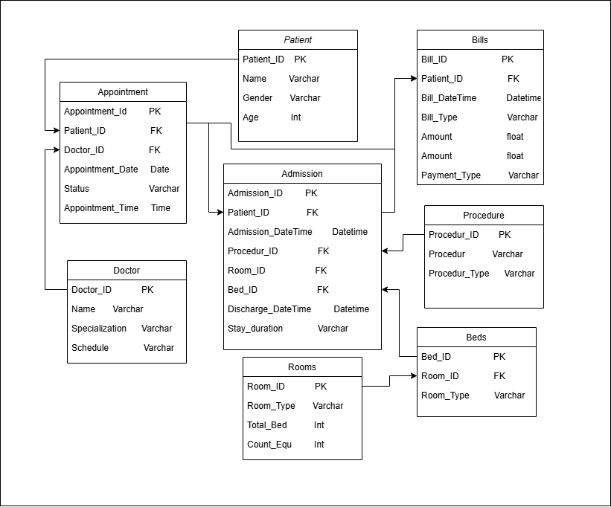

Fig 2.1: Data Architecture.

1. Dashboard Development in Power BI:

KPI Visualization: Displays key bits of knowledge like admission rates, bed availability, and patient demographics.

DAX Functions: Computes aggregate values such as average waiting time, patient stay duration, and total admissions.

GenAI-Powered Digital Assistant: Enhances dashboard usability by enabling natural language queries and AI-based bits of knowledge.

Below table [Fig 2.2] shows DAX Function.

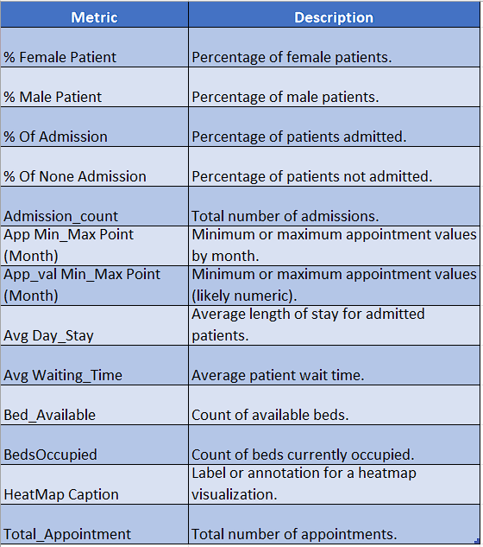

Fig 2.2: shows DAX Function.

## **IV. RESULTS AND DISCUSSION**

The Healing centre Dashboard Analytics Framework plays a noteworthy part in making strides both healing centre organization and clinical operations. The key encounters are:

1. Operational Insights:

Provides real-time taking after of bed inhabitance and resource availability.

Monitors hardware utilization patterns and monetary performance.

Enhances workflow viability and throughput optimization [11] in hospitals.

1. Clinical Insights:

Assesses understanding recovery rates, treatment viability, and readmission risks.

Monitors infection rates and unfavourable restorative events.

Analyses asset utilization for symptomatic and surgical procedures [12].

1. Predictive Capabilities:

Helps figure affirmation designs and beat persistent loads.

Identifies bottlenecks in clinic operations.

Provides AI-powered proposals for asset allotment and staffing decisions [13].

The comes about demonstrate that the dashboard essentially upgrades decision-making for healthcare experts by advertising real-time, data-driven experiences. AI-powered analytics empower healing centres to proactively oversee assets, optimize understanding care, and anticipate wasteful aspects. Future changes may connect IoT-based real-time observing and progressed AI models for prescient abnormality area.

## **V. DASHBOARD OVERVIEW AND FUNCTIONALITY**

The Hospital Dashboard Analytics System provides real-time monitoring and insights to optimize hospital management. The following key findings have been derived from the dashboard:

Below table [Fig 2.3] shows Dashboard result:

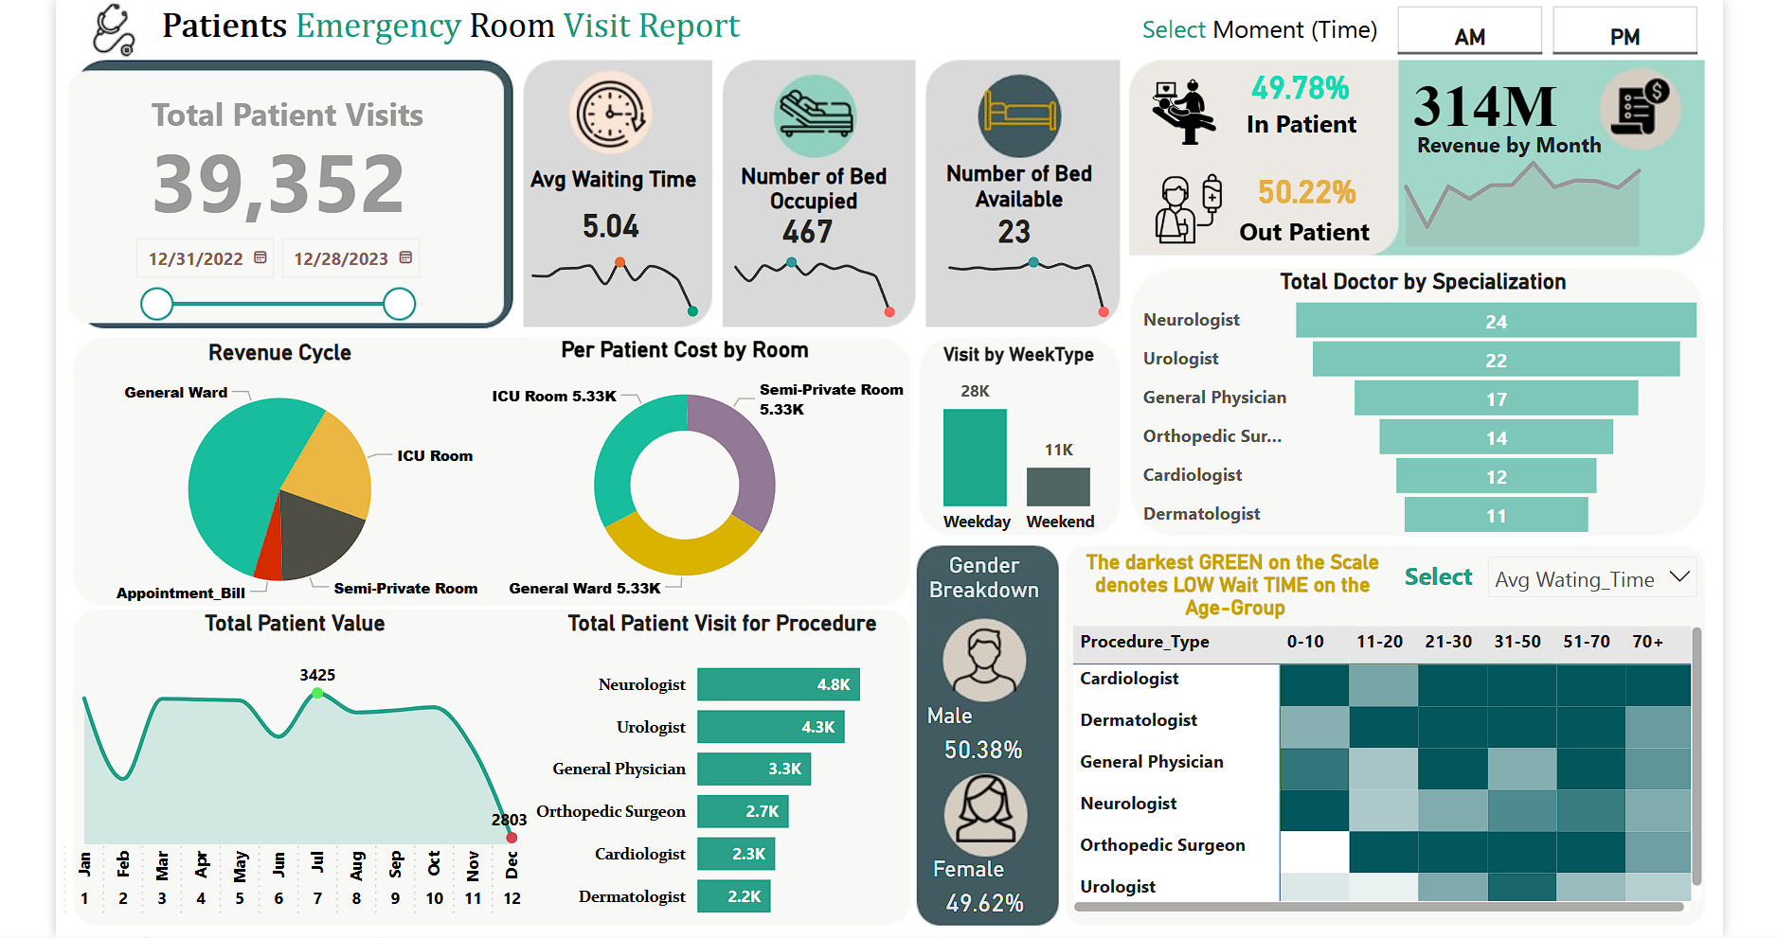

Fig 2.3: Final Dashboard Result.

1. Key Highlights and Functionalities

The dashboard comprises different visual components that provide data-driven insights for hospital administration. A few key segments include:

1. Admissions & Patient Flow:

Displays live patient admissions, discharges, and waiting lists.

Helps monitor occupancy trends and manage patient load effectively.

1. Bed Occupancy & Resource Utilization:

Real-time tracking of occupied, available, ICU, and emergency beds.

Predicts peak occupancy trends using AI-powered insights.

1. Financial Performance & Billing Analytics:

Tracks revenue sources, insurance claims, and departmental expenditures.

Helps hospital management identify cost-saving opportunities.

1. Predictive Analytics for Hospital Management:

Uses AI-based forecasting to predict admission trends, staffing needs, and resource allocation.

Provides automated insights to improve decision-making.

2. How the Dashboard is Dynamic and Interactive

Real-time Data Streaming: Ensures live updates for all key metrics.

Custom Filters and Drill-Throughs: Allows department-wise, doctor-wise, or time-specific analysis.

Role-Based Views: Different stakeholders (administrators, doctors, finance teams) can access customized dashboards.

3. Practical Value in Healthcare

Reduces manual reporting efforts, allowing hospital staff to focus on patient care.

Predicts peak admission times, improving staff scheduling and emergency preparedness.

Optimizes resource allocation, ensuring efficient hospital operations.

AI-driven risk assessment helps detect high-risk patients for better medical intervention.

## **VI. CONCLUSION**

The Hospital Dashboard Analytics Framework has effectively illustrated its capability to improve healthcare administration by integrating real-time data visualization, AI-powered insights, and predictive analytics. The framework provides hospital administrators, doctors, and decision-makers with a comprehensive view of key performance indicators (KPIs), allowing for more informed and data-driven decisions.

Through interactive dashboards, healthcare facilities can effectively monitor patient admissions, bed occupancy, resource utilization, financial performance, and patient demographics. The insights gained from the dashboard enhance operational efficiency, reduce waiting times, and improve patient outcomes by enabling timely interventions.

The incorporation of AI-driven recommendations and predictive analytics has enhanced decision-making processes, allowing hospitals to anticipate future admission trends, optimize staffing, and manage resources effectively. The framework also ensures financial sustainability by tracking revenue distribution across different hospital units.

Overall, the Hospital Dashboard Analytics Framework serves as a powerful tool for healthcare organizations, transforming hospital data into actionable insights. This research highlights the significance of data-driven healthcare management and paves the way for further advancements in predictive and prescriptive analytics in the medical sector.

**VII. FUTURE SCOPE**

The future potential of Healing Canter Dashboard Analytics is tremendous, with a few areas for upgrade and expansion:

1. Integration of IoT and Wearable Devices:

Real-time persistent checking, utilizing IoT sensors, can progress understanding care.

Smart clinic beds can give robotized bed accessibility updates.

1. Enhanced AI and Machine Learning Models:

More progressed prescient analytics can expect malady flare-ups and quiet readmission risks.

Anomaly discovery models can offer assistance distinguish operational wasteful aspects and extortion in healing centre billing.

1. Personalized Quiet Insights:

AI-driven experiences can personalize treatment plans based on chronicled understanding data.

Patient hazard stratification models can offer assistance in recognizing high-risk patients.

1. Blockchain for Secure Information Management:

Implementing blockchain can make strides information security, interoperability, and quiet information privacy.

Smart contracts can robotize charging and protections claim processing.

1. Integration with Government Healthcare Systems:

The dashboard can be connected with open wellbeing databases to progress policy-making.

It can help government organizations in following malady patterns and asset allocation.

1. Multi-Hospital and Cloud-based Analytics:

Expanding the framework to back different clinics in a bound-together dashboard.

Cloud-based arrangements will empower cross-hospital information comparisons and prescient modelling.

By joining these headways, the Healing Canter Dashboard Analytics Framework can advance revolutionize healthcare administration, make strides understanding care conveyance, and contribute to a more data-driven healthcare biological system.

**VIII. ACKNOWLEDGMENTS**

We sincerely thank 360 DigiTMG for providing us with the opportunity to work on this project. We also appreciate the guidance and support of our partners throughout this research. Additionally, we acknowledge the use of the CRISP-ML(Q) framework and ML Workflow, which are openly available on the official 360 DigiTMG website and used with their explicit consent.

**REFERENCES**

[1] Felix Parker, Diego A. Martínez, James Scheulen, Kimia Ghobadi. "An Interactive Decision-Support Dashboard for Optimal Hospital Capacity Management." <https://arxiv.org/abs/2403.15634>

[2] Mai Elshehaly, Rebecca Randell, Matthew Brehmer, Lynn McVey, Natasha Alvarado, Chris P. Gale, Roy A. Ruddle. "QualDash: Adaptable Generation of Visualization Dashboards for Healthcare Quality Improvement." <https://arxiv.org/abs/2009.03002>

[3] Mengdie Zhuang, Dave Concannon, Ed Manley. "A Framework for Evaluating Dashboards in Healthcare." <https://arxiv.org/abs/2009.04792>

[4] "CRISP-ML(Q) Framework: Cross-Industry Standard Process for Machine Learning with Quality Assurance." <https://360digitmg.com/mindmap/data-science>

[5] "Healthcare dashboards: 8 impactful models + metrics to track." Arcadia. Published: March 13, 2025. <https://arcadia.io/resources/healthcare-dashboard-examples>

[6] "Dashboards in Health Care Settings: Protocol for a Scoping Review." JMIR Research Protocols. Published: 2022. <https://www.jmir.org/2022/healthcare-dashboards>

[7] "Hospital Management - Healthcare Dashboards." Bold BI. Published: 2022. <https://www.boldbi.com/healthcare-dashboards>

[8] "13 Healthcare Dashboards and KPIs." NetSuite. Published: December 2024. <https://www.netsuite.com/healthcare-dashboards>

[9] "AI and Healthcare Dashboard Validation: Best Practices." JMIR Medical Informatics. Published: 2023. <https://www.jmir.org/2023/ai-dashboard-validation>

[10] "Secure Deployment Strategies for Healthcare IT." Healthcare IT Today. Published: 2024. <https://www.healthcareittoday.com/secure-deployment>

[11] "Operational Efficiency in Hospital Administration through Dashboards." BMC Health Services Research. Published: 2023. <https://www.biomedcentral.com/healthcare-administration-dashboards>

[12] "AI-Driven Insights in Clinical Decision-Making: A Review." Springer Healthcare Informatics. Published: 2023. <https://link.springer.com/article/ai-driven-clinical-decision>

[13] "Predictive Analytics for Hospital Management and Staffing Optimization." IEEE Transactions on Healthcare Systems. Published: 2024. <https://ieeexplore.ieee.org/document/hospital-predictive-analytics>